|  |  |  |  |
| --- | --- | --- | --- |
| **Lyng Primary School Knowledge Organiser** | | | |
| **Topic:** | **Victorians – Why does population change?** | Year 6  Civilisation, Communication and Inventions | Spring Term |



|  |  |
| --- | --- |
| **What Step On and Goldilocks words will I use?** | |
| **Spelling** | **Definition** |
| British Empire | The territories under the leadership or control of the British crown, including those in the Commonwealth of Nations and their colonies |
| Colony | When a group of people from one country build a settlement in another territory, or land. They claim the new land for the original country, and the original country keeps some control over the people who settled there. |
| Dr David Livingstone | David Livingstone was a Scottish physician and pioneer Christian missionary, an explorer in Africa, one of the most popular British heroes of the late 19th-century Victorian era |
| Exploitation of people | The action or fact of treating someone unfairly in order to benefit from their work |
| Exploitation of land | The action of making use of and benefiting from resources. |
| Imperialism | Extending a country's power and influence through colonization |
| Infrastructure | The basic physical and organizational structures and facilities needed for the operation of a society |
| Non-secular | A society where one religion is dominant. |
| Polarisation | Separation within a society that happens because of income inequality and results in a big difference between groups (rich and poor). |
| Population | The group of people who live in the same place. |
| Population distribution | How people are spread across a specific area. |
| Population density | A measurement of how many people are within a certain area. |
| Scramble for Africa | The invasion, occupation, division, and colonisation of African territory by European powers |
| Trade Agreement | When two or more countries agree on terms that helps them trade with each other. |

**Background information:**

The children will explore the British Empire and population changes. They will also practise identifying the most densely and sparsely populated areas and describe the increase in global population over time.

**Significant places**

* Britain
* Coal Mines
* British Empire
* Our locality

**Enquiry questions that we shall investigate during the topic:**

* How is the global population changing?
* What are birth and death rates?
* Why do people migrate?
* How is climate change impacting the population?
* How is population impacting our environment?
* How is population impacting our environment?

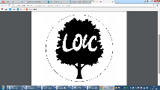

**Fieldwork Opportunities**

Trip to BCLM.   
•Follow a selected route on an OS map.

- Use a variety of data collection methods, including using a Likert scale.

•Collect information from the public.

|  |
| --- |
| **Key skills taken from Chris Quigley** |
| * Name and locate some of the countries and cities of the world and their identifying human and physical characteristics, including hills, mountains, rivers, key topographical features and land-use patterns; and understand how some of these aspects have changed over time. * Describe how countries and geographical regions are interconnected and interdependent. * Understand some of the reasons for geographical similarities and differences between countries. |

**Our Storytelling Approach to enhance engagement**

|  |  |  |
| --- | --- | --- |
| **People:**  A young orphan child | **Place:**  Workhouse, London | **Problem:**  **Need to flee and escape** |

**Global population distribution**

**Reasons for population growth**

**Map showing population density**

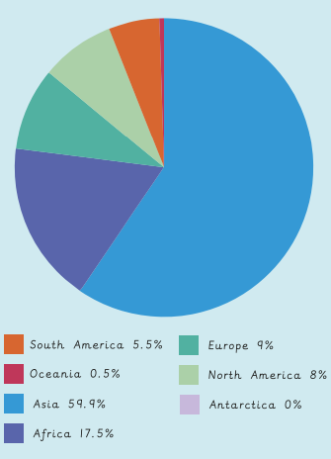

* Increase in birth rate.
* Decrease in death rate.
* Increase in immigration.
* Consistent access to food.
* Clean, spacious housing
* A stable job and income.

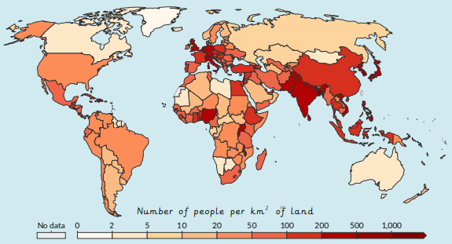

**Reasons for population decline**

**Map of British Empire**

* Decrease in birth rate.
* Increase in death rate.
* Increase in emigration.
* Little or no access to clean water.
* War and conflict.
* Little access to hospitals and medicine
* Natural disasters.
* Spread of diseases.

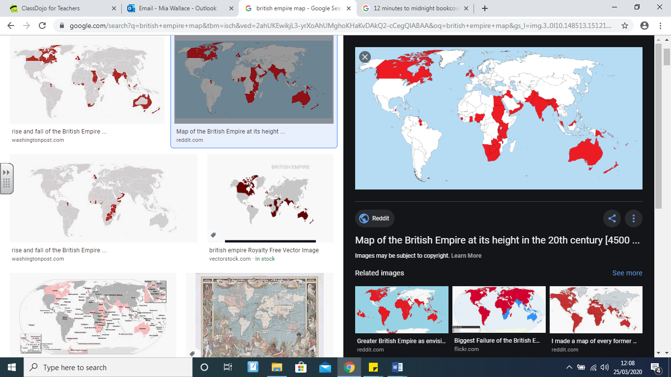

|  |  |  |  |
| --- | --- | --- | --- |
| **Lyng Primary School Knowledge Quiz** | | | |
| **Geography Topic:** | **Victorians – Why does population change?** | Year 6  *Civilisations, Communication and Inventions* | Spring |

|  |  |
| --- | --- |
| 6. Explain push/pull factors in migration. | |
| **S** |  |
| **E** |  |

|  |  |
| --- | --- |
| 1. What is an Empire? Think back to your Romans topic. | |
| **S** |  |
| **E** |  |

|  |  |  |
| --- | --- | --- |
| 7. Which is NOT an example of a push factor? | **S** | **E** |
| Little food or crop failure |  |  |
| Little access to healthcare |  |  |
| To be closer to family and friends |  |  |

|  |  |  |
| --- | --- | --- |
| 8. Greenhouse gases are a positive thing. | **S** | **E** |
| True |  |  |
| False |  |  |

|  |  |  |
| --- | --- | --- |
| 9. What does the word ‘quantitative’ mean in data collection? | **S** | **E** |
| A method of rating responses and opinions. |  |  |
| Involving a measurement or amount. |  |  |
| Involving a description of judgement or opinion. |  |  |

|  |  |  |
| --- | --- | --- |
| 1. Which of the following is a country in the British Empire? | **S** | **E** |
| 1. Germany |  |  |
| 1. Kenya |  |  |
| 1. France |  |  |

**Our Victorians/ Populations Geography Quick Quiz**

|  |  |
| --- | --- |
| 3. Write one legacy of the British Empire. | |
| **S** |  |
| **E** |  |

|  |  |  |
| --- | --- | --- |
| 4. What is a population density? | **S** | **E** |
| A measurement of how many people are within a certain area. |  |  |
| How people are spread across a specific area. |  |  |
| An area that contains many people relative to its size. |  |  |

|  |  |  |
| --- | --- | --- |
| 5. Migrants are people who move from one place to another. | **S** | **E** |
| True |  |  |
| False |  |  |

|  |  |
| --- | --- |
| 10. What could be done to decrease the level of litter in our locality? | |
| **S** |  |
| **E** |  |